Process Development and Characterization for Integrated Continuous Bioprocesses – Highlights from N-mAb
Kevin Brower^{1*+} , Kelly Wiltberger²⁺ , Claudia Berdugo³ , Allen Bosley⁴ , Elizabeth Goodrich⁵ , Valerie Pferdeort⁶ , Gene Schaefer^{7*}
1 Sanofi Kevin.Brower@sanofi.com , Purification Development – Mammalian Platform, Framingham MA USA
2 Biogen kelly.wiltberger@biogen.com , Biologics Development, Biogen, Research Triangle Park, NC USA
3 Catalent Claudia.Berdugo@catalent.com , Somerset, NJ USA
4 AstraZeneca allen.bosley@astrazeneca.com, Purification Process Sciences, AstraZeneca, Gaithersburg, Maryland, USA.
5 MilliporeSigma elizabeth.goodrich@milliporesigma.com , Process and Analytical Technology, Bedford, MA, USA
6 Biogen valerie.pferdeort@biogen.com, Cell Culture Development, Biogen, RTP, NC USA
7 National Institute for Innovation in Manufacturing Biopharmaceuticals (NIIMBL), gene@udel.edu Newark, DE USA
* Corresponding authors
⁺ Kevin Brower and Kelly Wiltberger contributed equally to this work.

ORCID:
Kevin Brower 0000-0002-3568-396X
Gene Schaefer 0000-0002-2937-8870

Abstract
The N-mAb case study [1] was produced by the National Institute for Innovation in Manufacturing Biopharmaceuticals (NIIMBL) to support teaching and learning for both industry and regulators to accelerate adoption of advanced manufacturing process technologies such as integrated continuous bioprocesses (ICB) for mAbs. Similar to the A-mAb case study [2] N-mAb presents the evolution of an integrated control strategy, from early clinical through process validation and commercial manufacturing with a focus on elements that are unique to integrated continuous bioprocesses. This publication presents a summary of the process design and characterization chapters to allow a greater focus on the unique elements relevant to that phase of development.
Introduction
The overall objective of process design should always be to ensure process stability, robustness, and control. To illustrate different scenarios and the associated decisions involving variation in product quality, examples of approaches to process development and characterization are developed based on an informed mock dataset generated from consensus industry experiences. This paper provides a condensed summary of the process design and characterization points to consider for an ICB, retaining key elements such as understanding critical decisions related to process design and critical quality attributes (CQAs), establishing relevant scale-down models using standard bench top equipment rather than using a fully scaled-down process replica, and approaches to analyzing the data generated during process characterization.
Overall Process Design
Numerous process options are possible for ICB. To make the discussion in the N-mAb case study more manageable and still retain some diversity to drive further discussion, two major process options are discussed, based on the presence or absence of a batch pool tank after low pH virus inactivation (Figure 1). A summary of the two process options is presented in Table 1 as a reference for the discussion in the next two sections. The inclusion of an intermediate batch pool tank rather than a surge tank can be tied to benefits as well as challenges as detailed in Table 2. Process design considerations related to bioreactor format, downstream unit operations, and integration strategies (i.e. surge tanks) are discussed.
Upstream Process Design
Integrated Continuous Bioprocess development within the upstream stages consists of work within the expansion stages, the perfusion production reactor, harvest via cell retention device, and overall media solution development optimized for the various stages. It is expected that the seed train for an intensified, continuous process will not differ significantly from the seed train currently employed by a fed-batch process. The N-1 reactor may be run either in batch, fed-batch, or as a perfused culture depending on the target transfer density desired per process design.
The N-stage perfusion production reactor can be run using one of two approaches: dynamic (flows in and out as well as the cell density profile will vary over time) or steady-state (inlet and outlet flow rates and other target parameters, such as cell mass, are maintained at constant value after start-up). In both scenarios, perfusion is initiated at the start of the batch to build cell mass to a significantly higher level than traditional fed-batch culture and protein is harvested continuously through a cell retention device and processed downstream in a connected manner. Significant differences in cell mass profiles, protein titer profile and batch duration are observed between dynamic and steady-state modes of operation (See Figure 2 for further illustration of example viable cell mass and titer profiles).
High productivity in the upstream N-stage is a key focus of development to meet product demands at a moderate scale of production while targeting a low cost of goods. A standard development approach may be applied to define the optimal setpoints of classical upstream operating parameters, leveraging historical fed-batch knowledge, where appropriate, and Design of Experiments (DOE). To establish key perfusion parameters, three phases of culture should be considered: growth, transition, and production. For steady-state cultures, the growth phase should optimize perfusion for high cell growth while the transition phase development optimizes for a rapid transition from growth to a productive steady-state to accelerate the shift to harvesting protein while minimizing variation in titer for more optimal downstream steps. The nutrient levels in the perfusion media need to be optimized to support cell health and to work in concert with the perfusion rate and cell bleed rate. Cell Specific Perfusion Rate (CSPR) is leveraged for single or multiple nutrient media solutions to address unique needs of the growth phase versus the steady-state phase. Upon studying the optimal CSPR in development, a fixed Vessel Volumes per Day (VVD) can be applied operationally assuming a known predictable growth profile, especially for steady-state perfusion. PAT tools can be leveraged for monitoring and control. While a high VVD perfusion rate may yield optimal growth, operational feasibility needs to be considered. For example, media concentrates (~2-10x) can be developed to minimize solution preparation and storage constraints. Cell separation is performed via alternating flow filtrations (ATF) or tangential flow filtration (TFF), both requiring an understanding of filter sizing, fouling, shear rates, flux rates, and protein retention (sieving). Given the filter performance will typically decline over time, planned filter change-outs may be required to support batch durations of 30 days or greater.
Product quality control has unique considerations when designing an ICB process given the continuous product stream versus a traditional batch that pools material at each unit operation step. It is critical to maintain product quality and impurities in the upstream steps within a range consistent with downstream capabilities over the protein collection duration. CQA vs non-CQA attribute classification should also be considered. In the scenario where product quality attributes are controlled consistently within the upstream target range, a fully ICB process (Fig 1, Option 1) design can be implemented. In the scenario where a CQA has significant variability and falls outside the upstream process range limit (as defined by downstream process capability and/or specifications), alternate choices in the ICB process design may need to be selected (e.g., batch pool tank, etc.). One example of product quality time-course profiles impacting the ICB design is illustrated via Figure 2c (glycosylation patterns for G2F and High Mannose species). In the ‘Steady’ scenario, glycosylation is deemed consistent enough to support end-to-end integrated downstream processing over the course of the batch. The ’Variable’ scenario illustrates a glycosylation pattern that is too variable relative to sub-lotted DS specifications, assuming the downstream process will not alter the high mannose levels produced upstream. Therefore, a batch pool step or further upstream development is required to minimize the variability of high mannose species over time. Since high mannose is considered potentially immunogenic and can also impact pharmacokinetics (PK), consistent levels should be maintained across the bioreactor duration [3]. Other product quality examples, for upstream development considerations, can be found within the full N-mAb publication.
Downstream Process Design
In general, most of the concepts typically applied to the design and development of a traditional batch purification may be applied for integrated and continuous purification. For example, process development studies for chromatography (i.e Protein A) within an integrated process are similar to those performed for conventional, batch processes. Existing tools for process development can be used to screen, assess, and select relevant parameters. The following paragraphs include specific examples where classical batch approaches may need to be adapted for an integrated and continuous process.
To accommodate a continuous feed exiting the bioreactor, an integrated capture process typically uses multiple columns in parallel. A key process development activity is the selection of the number and size of columns taking into consideration the binding capacity of the columns, the time required for non-loading steps, and the mass and volume flux entering the step. The selection of the number and geometry of columns has been described for a variety of configurations [4-7]. A second area of focus is development of the loading control strategy using an inline sensor and a methodology to either detect product breakthrough or estimate the loading [8, 9]. Effective load control normalizes the amount of material captured for each cycle and, correspondingly, the concentration passed forward to subsequent unit operations [4, 6, 7, 10]. It is critical to develop this loading control strategy using representative harvest covering the entire bioreactor duration. This is particularly important for dynamic perfusion where the composition of the harvest may vary significantly.
For virus inactivation, process development approaches leveraged for batch virus inactivation may also be applied for low pH or solvent / detergent methods in either a two-tank or plug flow reactor configuration. Batch approaches are applicable because engineering solutions have been developed to ensure consistent, controlled exposure to the virus inactivating condition (refs as included in final N-mAb). One key assumption is that low pH will not be achieved by “titrating against the peak” eluting from the capture chromatography step. Instead, homogenization of one or more eluates will be performed in a surge vessel or homogenizing tubular flow reactor. Without such a simplifying approach, significant titration development activities are likely required. A typical titration development experiment is depicted in Figure 3. In this example, the top portion of Figure 3 shows a scheme without a cycle surge vessel. Conversely, homogenization using a cycle surge vessel of one or more Protein A eluates, as shown in the lower portion of Figure 3, minimizes the variability. Model-based approaches may also be useful in predicting titration profiles [11].
Since virus filtration occurs substantially downstream and after polishing chromatography, much of the variability in feedstream quality and mass flow due to differences in steady state versus dynamic perfusion is expected to be mitigated, particularly when a post-capture chromatography cycle surge vessel is implemented. In a continuous process, virus filtration is most likely to be run under constant flow conditions rather than using constant-pressure control typical of batch processing. While membrane sizing during development can be performed using traditional pressure-driven methods [12], process capability under constant (low) flux over a long duration should be confirmed at small-scale prior to scaleup and prior to validation of viral clearance [13] . One significant difference between development of a virus filtration step for a continuous versus a batch process is the need to consider scaleup and implementation strategy in order to determine operating flux. The virus filter area should be selected based on how long it will be run, and this will have a direct impact on the process flux of the installed area. Changeout strategy and surge vessel sizing will impact the likelihood and/or frequency of process pauses, which should be included as part of viral clearance validation testing. Finally, methods to flush and test the virus filters pre/post use, coupled with methods for tracking and segregating product in the case of a post-use integrity test failure, should be built into the manufacturing control strategy.
For continuous UF/DF, two process options are considered: (1) a cycling system similar to batch and (2) a fully single-pass assembly, Figure 4. A cycling system can be implemented in two ways: (A) a single tangential-flow filtration (TFF) membrane assembly is connected to two recycle vessels that cycle back and forth between filling and the UF/DF operation or (B) two fully parallel systems. For either configuration, process development requirements will be largely similar to batch.
A fully single-pass UF/DF operation has the advantages of being truly continuous and requiring minimal hardware. However, robust scaleup and optimal process control are still being established in the industry. Membrane path length and crossflow setpoint are the primary drivers of overall conversion factor. Diafiltration in single-pass TFF mode can be accomplished via sequential product concentration and re-dilution with buffer over multiple sections of membrane with buffer added either co-currently or counter-currently. [14, 15]. Diafiltration process development will require characterization of the concentration factor target for each membrane section prior to re-dilution and confirmation that the target is robustly maintained over extended operation.
Integration Design Considerations
Some development considerations specific to continuous operations include 1) surge tank design and 2) process flow or residence time considerations, including in the bioreactor and integrated downstream train. In general, surge tank size should be minimized wherever possible to minimize product dispersion, and thereby maximize the controllability and traceability of product fluid elements moving through the system. Understanding the overall flow characteristics of the integrated process system and its variance can then be used to establish a relationship between sampling, testing, and how far forward in the process a decision or action could be taken.
SDM and Process Characterization
As with a batch process, process characterization activities are key to evaluating, improving, and demonstrating that the process design is robust and that it will meet quality and performance requirements. While the process could be viewed as several linked unit operations, the operation of these unit operations may be quite different in practice from that of a batch manufacturing process, and characterization of a continuous manufacturing process requires a scale-down model (SDM) capable of elucidating the impact of these differences. The design of either a steady-state or dynamic production bioreactor model, including the cell retention device, must account for the operating conditions needed to support a high cell density culture so that the biological environment and the resulting stresses on cellular performance can effectively represent the commercial-scale experience. For the downstream process, the scale down model could either be 1) traditional batch where each unit operation is studied independently, 2) partially connected where one or more steps are operated in sequence, 3) a pilot continuous model, 4) a mechanistic model or some combination of all four options. Regardless of the model selected, verification that the model is sufficiently predictive of the commercial scale is required.
Prior to execution of process characterization studies, a risk assessment should be conducted to identify variables and process/unit operations that may have an impact on product quality. While the considerations will be different for a continuous process, particularly the potential impact of variability in outputs from preceding steps, the assessment strategy selected does not need to differ from that used for traditional batch processes.
Upstream Process Characterization
Upstream process characterization carries the same general expectations as for a fed-batch process, but with a more complex set of controlled parameters and some unique design considerations due to harvesting product continuously for many days. Parameters identified above pre-defined risk acceptance levels should be evaluated in characterization studies to demonstrate process understanding and inform control strategies. Upstream controlled parameters to be studied in process characterization span both the growth and production phases of the process, whether operated in a dynamic or steady state manner. Parameters in the growth phase have the potential to impact the initial production phase performance which may or may not recover under controlled production phase operations. As a result, growth phase and production phase parameters identified for characterization should be evaluated in separate studies, in various statistical approaches, with the other phase operated at center point to isolate the impact of the appropriate phase parameters. Worst-case conditions identified from statistical models should be evaluated for long-term impact on process performance and product quality.
Due to the unique nature of the continuous bioreactor harvest and the extended duration of operation and control, the time dependency of titer and product quality attributes across process conditions must be understood. Process characterization studies should be executed for a sufficient duration to assess the full impact of parameter effects through the entire harvest duration and support batch definition strategies (e.g., fully continuous or downstream pooling).
Prior knowledge, development optimization, and screening studies may all be leveraged to identify parameters with process or product impact not expected to be involved in significant interactions. These parameters may be studied in one factor at-a-time (OFAT) experiment. More complex statistical methods, such as design of experiments (DoE) or Bayesian hierarchical modeling, can be leveraged to explore the process operating space across controlled parameters expected to have significant process and product quality impacts and/or interactions. Traditional and mixed model DoE applications may require multiple statistical models across the design space to account for the potential impact of time on the response from controlled parameters. As an alternative, Bayesian hierarchical modeling offers a potentially more efficient analysis of linear and non-linear relationships by treating time as a random variable. The outcomes of time and fixed control parameters are presented as probability distributions and can be leveraged for predictive purposes similar to traditional DoE methods. An example of a Bayesian application is presented below, with further comparisons of traditional DoE and Bayesian approaches available in the full N-mAb manuscript.
Bayesian analysis generates expected distributions of response variables from complex non-linear multivariable functions. To illustrate this application, consider the scenario where nutrient levels and declining viability in a dynamic continuous process result in a non-linear time-dependent increase in high mannose species at varying perfusion rates (see Figure 5a).
A suitable exponential mathematical function can be identified through model fitting to best capture the observed response in the full characterization data set as a function of time alone, independent of perfusion rate. The original data set of varying perfusion rates across the dynamic production phase are then fit to the new model equation accounting for both time and perfusion rate impacts. In this way, any complex interaction between controlled parameters can be modeled by the Bayesian approach and all model coefficients can be estimated by posterior distributions, as shown in Figure 5c.
The predictive power of Bayesian analysis allows the application of posterior distributions of controlled parameters to establish expected performance responses at designated levels of confidence. This allows a risk-based approach to establishing controlled parameter ranges as a function of time during the production phase, while ensuring a level of certainty to meet product quality and process performance targets. In this example, -5.73% is the largest change in perfusion rate from control that would ensure (with 95% confidence) that high mannose levels of material harvested through day 14 would not exceed a hypothetical specification limit of 16% (see Figure 5b).
Downstream Process Characterization:
For illustrative purposes, the downstream process characterization section of N-mAb focuses on downstream integrated with a dynamic perfusion bioreactor, without breakthrough load control on the capture column. This scenario was selected because it provides interesting processing challenges as product titer, quality, and impurity levels change over time. It leverages the same strategy applied to batch unit operation process characterization, while also incorporating additional unique aspects resulting from continuous or connected downstream unit operations. The overall approach can be categorized into four activities: screening studies, process characterization studies, model-based worst-case or linkage studies, and linkage studies using discrete or connected downstream unit operations.
Screening studies largely follow a traditional pool-based strategy to determine the parameters within each downstream unit operation with the most significant effects on process and product quality attributes, which would be carried forward for evaluation in the full characterization studies, while eliminating parameters having little or no impact.
Due to the unique aspect of connected downstream unit operations, additional parameters that may impact process conditions in the preceding or subsequent steps should also be studied during process characterization to provide insight into performance and robustness. For example, the variability of material attributes in feed stock over time, unexpected pauses or loss of cycles may impact process performance. Additionally, when adding a new step for the purpose of connecting downstream unit operations, such as in-line titration, input parameters (e.g., pH and conductivity) are controlled indirectly as output parameters from previous steps. Evaluating variability of these input parameters would allow verification that process parameters are controlled by previous steps.
In our example, OFAT screening studies for Protein A Capture Chromatography showed temperature and technical pause duration had no impact on product quality and were excluded from further characterization studies. Parameters carried forward for a DOE response surface methodology (RSM) study using a discrete (batch) scale down model were loading, culture age, loading/wash residence times, elution pH, and elution conductivity. Loss of Protein A cycles is evaluated in a linkage study.
A wide characterization range for loading is evaluated due to the high variability in harvest titer expected in dynamic perfusion coupled with fixed volume loading (no breakthrough loading control) on the capture column. Both high and low loading could impact product concentration in the Protein A pool, resulting in variability of input parameters to the subsequent viral inactivation step, and potential variability in pH depending on how titration is performed (fixed ratio, feedback/forward control, algorithmic control). Similarly, variation in elution pH could impact pH of the Protein A pool and lead to pH variability during viral inactivation. A linkage study may be performed to address these interactions if the DOE results indicated impact to product quality.
To evaluate potential impact of feed stock variability, a failure mode and effect analysis (FMEA) is performed to consider changes in titer, cell viability, product quality, and ratio of impurities to product as the culture progresses from low titer and potentially high impurity ratio near the beginning, through highest cell density and titer near the peak of production, to lowest cell viability and high impurities near the end of the run. At each of these points, the potential impact on capture column performance and elution characteristics is assessed. Then, two different experimental studies can be designed: one where the age of harvested cell culture fluid is included as an input to the process characterization DOE, or one where the DOE is performed three times using load material from the different culture timepoints.
In our example, the first design was used for the process characterization study. Product quality outputs of the experiments were high molecular weight species and host cell protein; DNA and leached protein A levels were also monitored. Statistical analysis was performed after the DOE study. Statistically significant effects (p < 0.05) were detected, and a predictive model was developed for the inputs and outputs. The multivariate experimental design revealed the parameter impacts on step performance and product quality that led to additional linkage studies. Parameter setpoints and ranges, as well as the design and results of screening and characterization studies, are shown in Table 3 for selected steps.
For the remaining downstream purification steps, a similar workflow was employed. The controlled parameters studied are well aligned with those used in the A-mAb case study.
Worst Case Linkage Assessments
Processes designed with continuous unit operations that are integrated without a batch pool vessel introduce certain special considerations. After all DOE RSM studies are completed, linkage assessments such as those described below, should be performed either by process model or experimentally.
Linkage Study to address the impact of the age of HCCF - As described in Section 3.5.2.1, results from DOE RSM studies show that the age of HCCF impacts % HMWS in the ProA pool. The worst-case HCCF sample (Day 14 +/-1 day) with %HMWS at 3.2% could be processed by viral inactivation and Polishing Chromatography 1 and 2 using discrete scale down models one step at a time.
Model-based Linkage Study to address the loss of cycles -Because the product quality varies as a function of cell culture duration, the loss of product cycles can ultimately impact the product quality in the combined pool, but the impact is predictable. Failure mode assessment is performed to evaluate how final product quality attributes, such as % HMWS, which varies over the bioreactor duration, might be affected by the loss of cycles during a run.
Model-based or experimental Linkage Study to assess varying outputs from previous unit operations
Using data from characterization studies, the expected range for process outputs, such as protein concentration, pH, and conductivity can be modeled. These expected ranges can be assessed for impact on subsequent steps by leveraging the characterization data from those unit operations, such as to what extent Protein A loading conditions impact protein A pool concentration and pH. If the output ranges from a unit operation were not assessed as load conditions for the subsequent step, then additional experimental linkage studies may be required.
Viral clearance validation at small scale
In general, viral clearance approaches traditionally applied to batch processes may also be applied to integrated continuous systems. Similarities and differences are discussed for each unit operation below.
Multi-column capture (or polishing) may require specific consideration. For example, continuous small-scale equipment may not be available at viral clearance facilities. Instead, continuous capture systems leveraging two columns in series in the load phase may use a batch chromatography system with a modified flow path.
Several studies have demostrated that the viral clearance capabilities of a multi-column continuous Protein A system may be evaluated using an appropriately scaled‐down single column setup by comparing model virus removal over single column and multi-column systems [16, 17]. Similar virus removal was achieved for both single column and mutli-column systems and parameters identified as impactful for viral clearance using the single column system were predictive for multi-column modes.
Virus inactivation (low pH or solvent / detergent) in a continous system may be performed in hold tanks, as is done for batch processing, and multiple hold tanks may be used to minimize disruptions in the process flow. Operationally, each hold tank is similar to batch processing, and therefore batch scale-down models can be used. Additionally, if a continuous incubation chamber is used at scale, a batch scale-down model could still be appropriate to assess impacts to viral inactiviation and product quality. In this instance the ability of the continuous incubation chambers to control the processs parameters with the ranges identified by the batch scale down model would need to be demonstrated separately.
For the polishing steps that can be dynamically influenced by their prior unit operation, the viral clearance validation approach can become more operationally challenging. In this scenario, product concentration and conductivity/pH both change during loading onto the polishing step. One apprach would be to mimic this configuration during the viral clearance study using two connected bench-scale unit operations, however, this set-up significanlty complicates the viral clearance study. Alternatively, a discrete scale-down model of this polishing step can be operated as a stand-alone step for the viral clearance study. In this model, the homogenous load to the polishing step represents the worst-case condition possibly produced by the prior step. This approach is feasible only if the worst-case conditions can be identified by bracketing experiments covering the range of expected dynamic conditions.
Traditional approaches to viral clearance validation for viral filtration should apply directly to integrated processing. Adaptations to traditional study design to accommodate longer pause durations and/or lower volumetric fluxes may be incorporated. In the absence of a cycle surge tank, impact due to feed stream heterogeneity will need to be studied and, if necessary, mitigated. In the absence of a cycle surge tank, a continuous process could result in a virus filter inlet stream with well-controlled but variable product concentration, buffer composition, and flow rate or pressure, especially if the preceding step is operated in bind and elute mode. The impact of feed concentration on flux and filter capacity has been demonstrated for Viresolve Pro (Millipore-Sigma) [12] as well as Planova 20N and BioEX (Asahi) nanofilters [18]. The variability in the feed stream is a challenge to simulate during viral clearance studies. To overcome this challenge, the validation of the virus filter may be performed while it is directly connected to a bench-scale chromatography system using an in-line virus injection method, thus enabling the most representative feed conditions for the virus filter. However, it is expected to be more practical or feasible to validate the virus filter as a stand-alone step.
Another consideration is the model virus stability, which could be addressed by 1) using a modified spiking strategy [12, 18] , 2) use of minute virus of mice (MVM) as a worst-case model virus due to its small size and relatively high stability [19] , and 3) or executing studies with non-infectious virus-like particles to elucidate the worst-case conditions for virus retention during a stand-alone virus filtration validation study.
Demonstration of performance at-scale
Operation of the process at the proposed full scale may be considered as an integrated part of process development, as certain sensitivities are more readily observed at full scale. This approach would reduce the need for a fully integrated bench-scale model. In addition, initial runs at the intended manufacturing scale can provide important information about certain elements of process performance that are difficult to assess through the use of scale-down processes. For example, an assessment can be done of the performance of overall mass flow management of the continuous system as a whole as it relates to process flowrates, surge tank sizing, and potential unit operation variability, as well as experience with actual residence time. Effective demonstration of integration, including process analytical technology control elements, advanced automation, and respective responses to disturbances can be obtained. Additionally, valuable experience with batch start-up and transient changes can be gained.
Another potential advantage of assessing process peformance at scale could be a reduction in the number of process performance qualification (PPQ) runs required. This experience could be obtained through full-scale campaigns in either clinical GMP or non-GMP (pilot) settings. When evaluating the process at scale, it is important to collect sufficient data around the various unit operations over time to ensure the performance predicted from SDM studies has been realized, as well as to establish a reasonable set of acceptance criteria for Stage 2 PV or PPQ. It is also important to collect additional data to support microbial control by the process, especially for systems with complex automation or valving. Note that in the prototype sampling plan shown in Figure 6 the color of the sample points reflects either an in-line measurement (orange) or a sample point for offline testing of either process performance or quality attributes (teal). The development of an overall integrated control strategy is addressed in detail in the full N-mAb case study.
Conclusion
The N-Mab case study represents an opportunity to discuss and describe industry perspectives related to the design, development, and characterization of an integrated continuous bioprocess. As was true for the A-Mab case study, N-Mab represents a single point in time for a continually evolving industry. N-Mab has potential to serve as teaching document for established and emerging biotechnology practitioners alike. Accordingly, we welcome readers to engage with this manuscript and, especially, the full N-Mab Case Study, which includes additional detail on the topics discussed herein as well as chapters on Validation, Quality, and Control Strategy aspects related to continuous biomanufacturing.

References
1. NIIMBL, N-mAb: A case study to support development and adoption of integrated continuous bioprocesses for monoclonal antibodies Version 1, N.I.f.I.i.M. Biopharmaceuticals, Editor. 2022: www.N-mab.org.
2. CMC Biotech Working Group Emeryville, C.C., 2009, A-Mab Version 2.1: A Case Study in Bioprocess Development. 2009: Emeryville, CA.
3. Mastrangeli, R., et al., The Formidable Challenge of Controlling High Mannose-Type N-Glycans in Therapeutic mAbs. Trends in Biotechnology, 2020.
4. Godawat, R., et al., End-to-end integrated fully continuous production of recombinant monoclonal antibodies. Journal of Biotechnology, 2015. 213: p. 13-19.
5. Vogg, S., T. Müller-Späth, and M. Morbidelli, Current status and future challenges in continuous biochromatography. Current Opinion in Chemical Engineering, 2018. 22: p. 138-144.
6. Gillette, K., M. Bisschops, and M. Schofield, Development and optimization of multicolumn chromatography for mAb perfusion processes. Journal of Chemical Technology & Biotechnology, 2021.
7. Baur, D., et al., Comparison of batch and continuous multi-column protein A capture processes by optimal design. Biotechnology Journal, 2016. 11(7): p. 920-931.
8. Chmielowski, R.A., et al., Definition and dynamic control of a continuous chromatography process independent of cell culture titer and impurities. Journal of Chromatography A, 2017. 1526: p. 58-69.
9. Thakur, G., V. Hebbi, and A.S. Rathore, An NIR-based PAT approach for real-time control of loading in Protein A chromatography in continuous manufacturing of monoclonal antibodies. 2020. 117(3): p. 673-686.
10. Vogg, S., T. Müller-Späth, and M. Morbidelli, Design space and robustness analysis of batch and counter-current frontal chromatography processes for the removal of antibody aggregates. Journal of Chromatography A, 2020. 1619: p. 460943.
11. Thakur, G., P. Ghumade, and A.S. Rathore, Process analytical technology in continuous processing: Model-based real time control of pH between capture chromatography and viral inactivation for monoclonal antibody production. Journal of Chromatography A, 2021. 1658: p. 462614.
12. Bohonak, D.M., et al., Adapting virus filtration to enable intensified and continuous monoclonal antibody processing. Biotechnology Progress, 2021. 37(2).
13. Johnson, S.A., et al., Virus filtration: A review of current and future practices in bioprocessing. Biotechnology and Bioengineering, 2022. 119(3): p. 743-761.
14. Coolbaugh, M.J., et al., Pilot-scale demonstration of an end-to-end integrated and continuous biomanufacturing process. 2021. n/a(n/a).
15. Zydney, A.L., Perspectives on integrated continuous bioprocessing—opportunities and challenges. Current Opinion in Chemical Engineering, 2015. 10: p. 8-13.
16. Angelo, J., et al., Virus clearance validation across continuous capture chromatography. Biotechnology and Bioengineering, 2019. 116(9): p. 2275-2284.
17. Chiang, M.J., et al., Validation and optimization of viral clearance in a downstream continuous chromatography setting. Biotechnology and Bioengineering, 2019. 116(9): p. 2292-2302.
18. Lute, S., et al., Development of small-scale models to understand the impact of continuous downstream bioprocessing on integrated virus filtration. Biotechnol Prog, 2020. 36(3): p. e2962.
19. Gefroh, E., et al., Use of MMV as a Single Worst-Case Model Virus in Viral Filter Validation Studies. PDA Journal of Pharmaceutical Science and Technology, 2014. 68(3): p. 297-311.
Tables and Figures

Table 1 Summary of major and minor process options discussed in N-mAb.
Process Stage | Option 1  ICB: Stages 1-7  Cycled Batch: Stage 8 | Option 2  ICB: Stages 1-4  Periodic Batch: Stages 5-8 | Other Options Discussed | Differences from Batch Operation and Other Comments
Stage 1  Preculture | N-1 batch or perfused N-1
Stage 2a  Production Bioreactor | Steady-state perfusion or  dynamic perfusion |  |  | Potential for variations in product quality and titer, especially for dynamic perfusion
Stage 2b  Cell Removal | TFF or ATF |  |  | Potential for product retention and fouling
Unit Op Connection | Surge tank
Stage 3  Capture Chromatography | Continuous multi-column chromatography (MCC): one column always being fed |  | Dual-column: alternating loading of columns | Varying load material in terms of titer but still controlled within PAR/NOR limits. Feed may be paused between column loads for dual column
Unit Op Connection | Cycle surge tank
Stage 4  Virus Inactivation | In-line viral inactivation in a continuous plug flow reactor |  | Alternating batch tank pH incubation | Continuous operation with occasional variations in protein concentration
Unit Op Connection | Surge tank | Batch pool tank |  | Option 2 batch pool tank represents batch attributes
Stage 5  F/T Polishing Chromatography | Dual-column alternating loading of columns Note that this is essentially the same as continuous MCC: one column always being fed since load duration >> all other step durations |  |  | Varying load material but controlled within PAR/NOR limits  Feed may be paused between column loads for dual column
Unit Op Connection | Surge tank | Cycle Surge Tank | Size of surge tank
Stage 6  B/E Polishing Chromatography | Continuous MCC: one column always being fed | Dual-column alternating loading of columns |  | Varying load material but controlled within PAR/MOR limits  Feed may be paused between column loads for dual column
Unit Op Connection | Surge tank | Cycle Surge Tank | Size of surge tank
Stage 7  Virus Filtration | Alternating batch set-up, pre- and post-integrity test |  | Continuous operation | Varying protein concentration in load material
Unit Op Connection | Surge tank in UF/DF | Surge tank
Stage 8  Concentration & Diafiltration into Formulation Buffer | Two-tank batch UF/DF: alternating use of tanks as surge & TFF recycle |  | Continuous SP-UF1 w/countercurrent DF & SP-UF2  Two parallel batch UF/DF systems operated in an alternating mode | Continuous operation, varying protein concentration  Decisions around need for a surge tank vs use of two tanks integrated into the UF/DF skid will depend on unique volumes involved in a particular process design
Unit Op Connection | Batch pool tank or multiple bags |  | Surge tank or individual bags to be pooled later | Batch pool tank represents batch attributes; batch consolidation could occur immediately after UF/DF or as part of formulation step to create DS

Table 2. Definitions of Surge, Cycle Surge, and Batch Pool Tanks
Surge Tank | Cycle Surge Tank | Batch Hold Tank
Increasing Hold Time/Volume
PURPOSE
- Serve as break tank  - Accommodate small fluctuations in flow between unit operations  - Manage pressure differences | - Accumulate one (or a few) sub-cycles exiting a unit operation.  - Useful for unit op with highly variable output, e.g., bind and elute  - Allows for homogenization before passing to next unit operation  - Designed for cyclic output volume from a unit operation | - Accumulate material equivalent to the mass of a single drug substance lot  - Allows for collection and homogenization  - Minimize impact of upstream product quality variability
RESIDENCE TIME
Minutes to tens of minutes | Hours | 24 hours or more
KEY CONSIDERATIONS
- May lead to material loss in case of significant disruption at unit op interface | - May impact residence time broadening, traceability | - Typical locations include post-Capture or after UF/DF  - May require a large vessel and demonstration of product stability

Table 3 Summary of downstream controlled parameters and results of process characterization.
Unit Ops | Downstream Controlled Parameters | Unit | Set Point | Operating Range | Characterization Range | Screening Outcome or Characterization Study Recommendation
Capture (ProA) Chromatography | Temperature | °C | 20 | 15–25 | 15–25 | Screening OFAT – no impact on product quality observed
 | Loading/Wash Residence Time | min | 6 | 5–7 | 4–8 | Process Characterization - DOE RSM
 | Loading (from Dynamic Perfusion) | g/L | 50 | 10–55 | 5–60 | no significant impact on quality or performance – no linkage study needed
 | Elution pH | units | 3.5 | 3.4–3.6 | 3.3–3.7 | Process Characterization - DOE RSM
 | Elution conductivity | mS/cm | 3.5 | 3–4 | 2–5 | followed by linkage study due to impacts on %HMWS, HCP and elution pH
 | Technical Pause Duration | min | n/a | n/a | Up to 30 min | Screening OFAT – no impact on product quality observed
 | Age of HCCF | days | n/a | n/a | Days 1, 8, and 10 | Process Characterization – DOE RSM or special OFAT
 | Loss of ProA cycles | % | n/a | n/a | 20% at beginning, 20% at end, 20% evenly distributed | Process Characterization - Linkage study
Virus Inactivation | low pH Target | units | 3.5 | 3.4–3.6 | 3.3–3.7 | Process Characterization - Worst Case
 | Incubation Duration | min | 65 | 60–70 | 55–75 | Process Characterization - Worst Case
 | Protein Concentration (no BT load ctrl) | g/L | N/A | 5–18 | 3–20 | Screening OFAT – no impact on product quality observed
 | Post-Incubation pH (no BT load ctrl) | units | 7.0 | 6.8–7.2 | 6.5–7.5 | Screening OFAT – no impact on product quality observed
 | Acidic titrant to product ratio | % | process-dependent | process-dependent | +/- 10% | Screening OFAT for pH as output of titration - well within characterization range
 | Basic titrant to product ratio | % | process-dependent | process-dependent | +/- 10% | Screening OFAT for pH as output of titration - well within characterization range

Figure 1: Two major process options for continuous operation of an integrated continuous bioprocess. Option 1 is a continuous process until the surge or retentate tank before the SPTFF or UF/DF step where it becomes a cycled batch process. Option 2 is an integrated process through low pH hold and then switches to a periodic batch process through polishing chromatography and beyond.
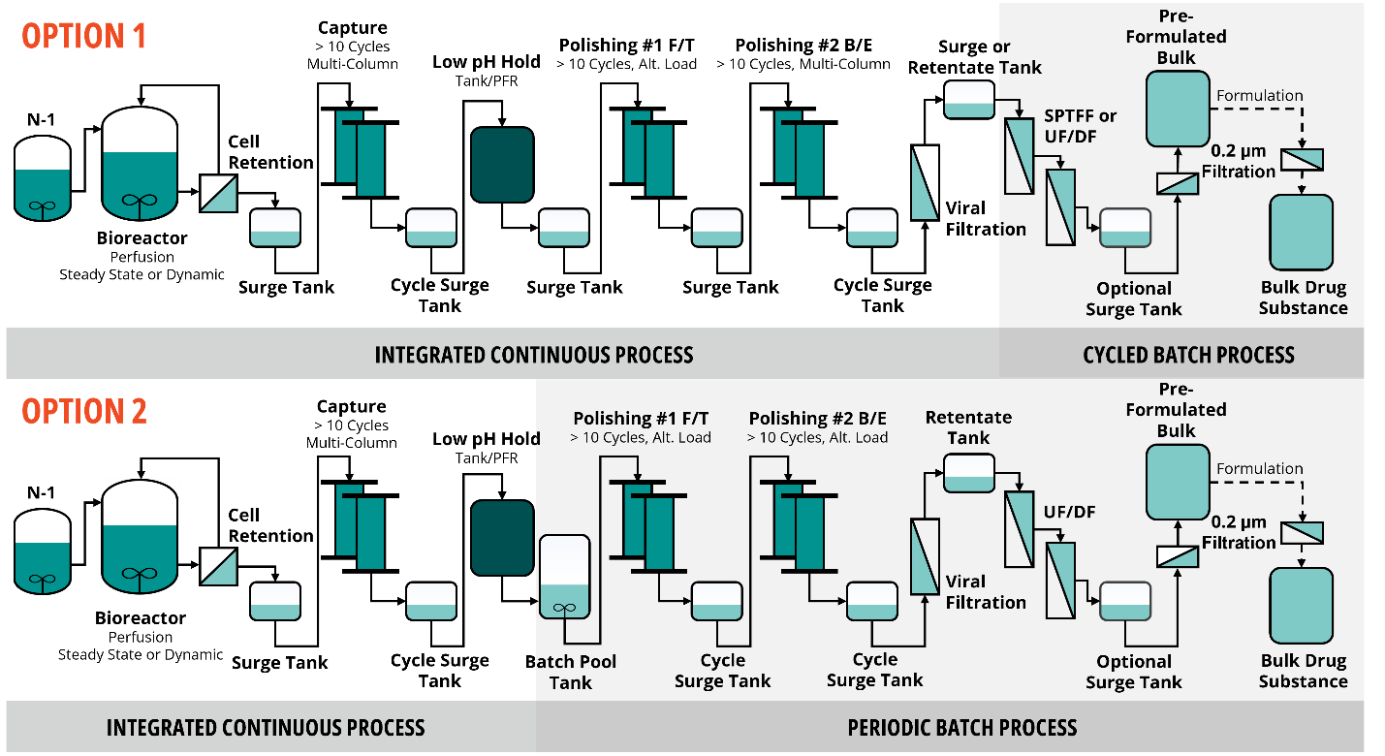

Figure 2. Time profiles of viable cell mass (A) and harvest titer (B) for steady state and dynamic perfusion operating modes. Glycosylation variants as a function of normalized bioreactor day for examples of steady and variable performance in the bioreactor (C).
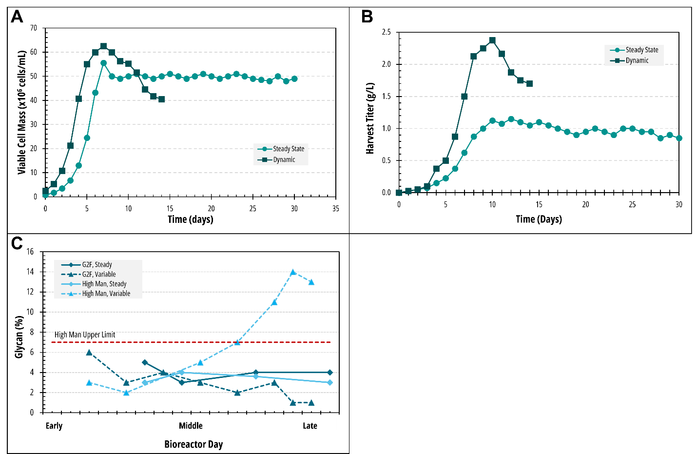

Figure 3. Comparison of simulated input variability and output control for pH for virus inactivation with (A) and without (B) cycle homogenization (titrating against the peak).
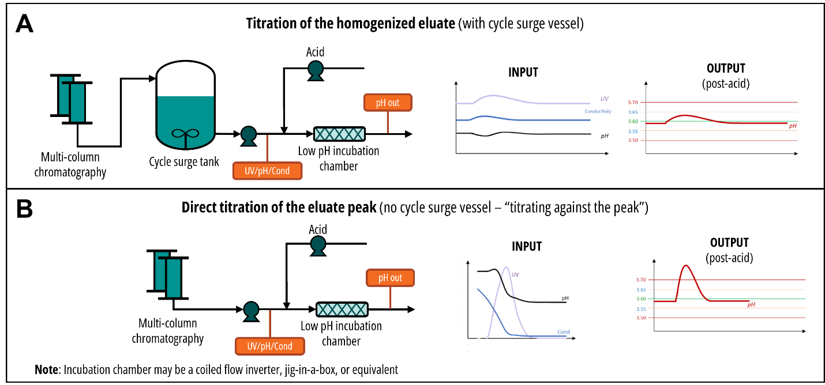
Figure 4 Continuous UF/DF using a cycling system: confiuration using one TFF system connected to two recycle vessels (A) or using two parallel TFF systems (B). Continuous UF/DF using a fully single-pass system run in either a co-current (C) or counter-current (D) configuration.

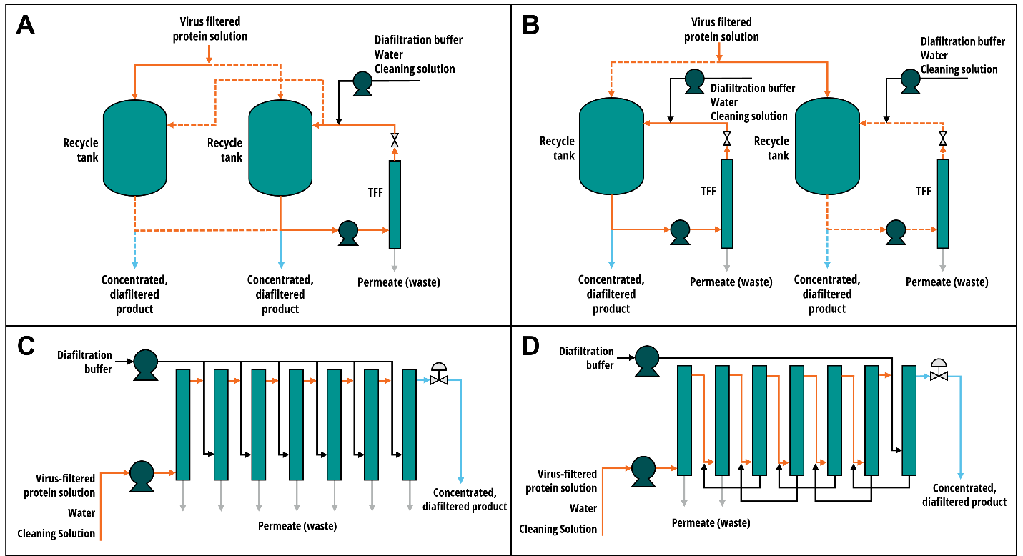

Figure 5 High mannose trajectory (A-left) and cell viability (A-right) in the bioreactor for a variable product quality scenario. Application of the Bayesian model to develop a control strategy such that with a 95% probability, what percentage change in the target perfusion rate is required to ensure that the high mannose on Culture Day 14 is no more than a limit of 16% as well as the full probability density plot (B). Using the posterior distributions of the model parameters, the posterior predictive distribution of the % High Mannose can be generated at different levels of percent change of target perfusion rate and as a function of culture day (C).
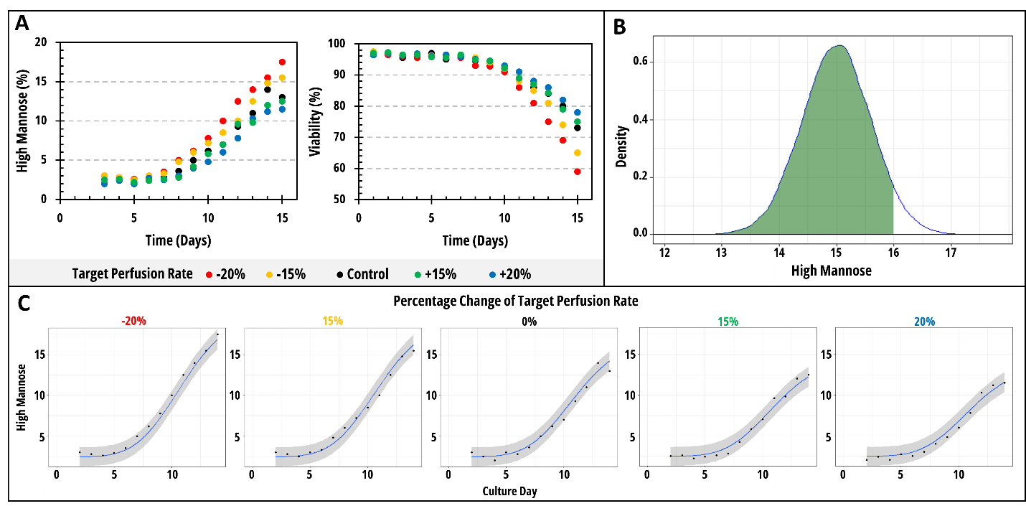

Figure 6 Prototype analytical sampling and testing plan for initial clinical runs through Process Performance Qualification
